

INSTRUCTIONS
Read the instructions carefully before starting the process

Install MS-OFFICE 2007 in your system
- Download the MS Access database student.mdb from the E-mail (regrabsection@buc.edu.in) (also available in www.b-u.ac.in) and store it in the local hard disk.
- Open the downloaded student bio.mdb database to start the process.

MS Access Database name : student bio.mdb

Table name : i) BIODATA
ii) CMASTER
ii) COLLMAST

Data entry

- Double click the downloaded student.mdb database which leads to a MAIN MENU screen as shown below
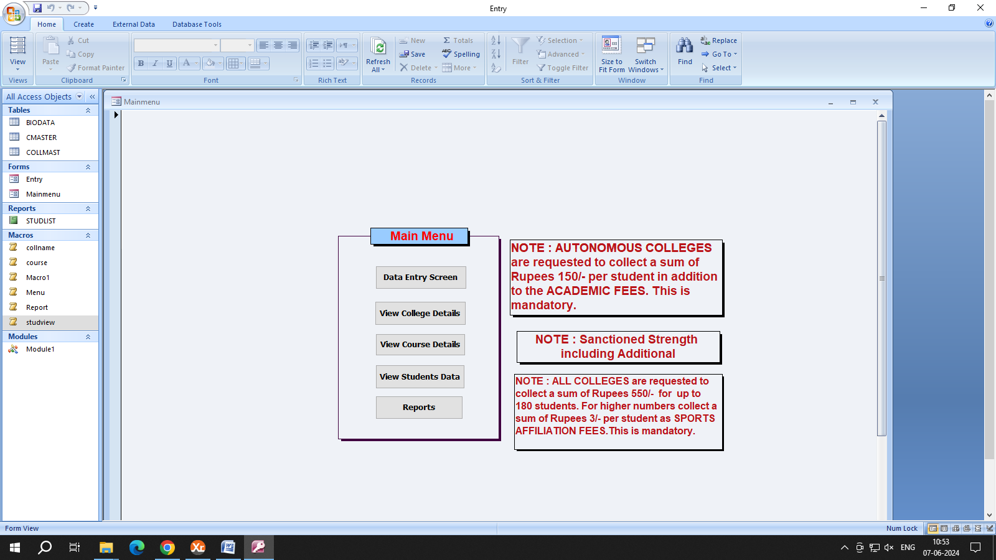

- Click the option DATA ENTRY SCREEN to start the data entry. A sample data entry screen is shown below.
- Enter the student data and to get it saved and go to next record click the arrow mark which is available with * at the bottom left of the data entry screen.
- To perform any corrections in the saved record click the arrow mark (which indicates previous record) to go to that particular record and do the modifications.
- After completing the entire data entry process file student bio.mdb to Registrar’s Office A & B section E-mail – regrabsection@buc.edu.in and send to the Controller of Examinations email coe.edp@buc.edu.in
Click this for Delete Record
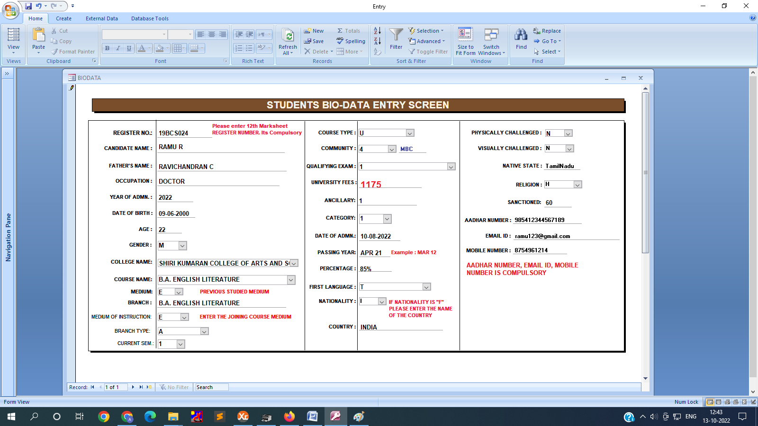
Click this button to add a new record also to save the record
Click this button to view last record
Click this button to view next record
Shows the total records
View Previous record
View First Record

Database Fields and its description

*All the fields should be entered compulsorily and in Capital letters.
  - Register number : Student’s Register number
  - Name : Name of the candidate as per SSLC Mark sheet.
  - Father’s Name : Father’s Name
  - F.Occupation : Father’s Occupation
  - Year of Admn. : Current Year(2026)
  - Age : Student’s age
  - Date of Birth : Date of Birth as per SSLC Mark sheet
  - Sex : Male candidate (M)
Female candidate (F) Transgender (T)
9. Category : Refer COE’s Instructions
10. Medium : Previous studied medium
- English (E)
- Tamil (T)
11. Branch : Refer COE’s Instructions
12. Medium of Instruction : Joining Course medium
- English (E)
- Tamil (T)
13. Branch Type : Type of the Course
A - Arts
S - Science
C - Commerce
M - Management
V - Vocational
CR - Certificate Course
D - Diploma Course
PD – PG Diploma Course
- Current Sem. : I Semester (1)
II Semester (2), etc.,
- College code : Refer COLLMAST table
- Community : OC – 1, BC – 2, BC(M) - 3, MBC – 4, SC – 5, ST – 6, SCA – 7,
SCC – 8, DNC – 9.
- Course code : Refer CMASTER table
- U/P/C/D/PD : UG (U), PG (P), Certificate (C), Diploma (D), PG Dip. (PD)
- Qualifying Exam : For Tamilnadu Candidates -1
For Other Boards - 2
Foreign Candidates (UG/PG) - 3
BU admitted for PG - 4
Other Universities - 5
Diploma for SBTE
Certificate Course
PG Diploma Course - 6

- University Fees : Tamilnadu candidates (UG) : 1175/-
Other Boards (UG) : 1825/-
Foreign candidates (UG) : 8450/-
Foreign candidates (PG) : 14375/-
BU admitted PG : 675/-
Other Universities PG : 1750/-
Certificate / Diploma : 300/-
PG Diploma candidates : 375/-
Sports Affiliation Fees : Upto 180 Students Rs.550/-
Above 180 Students – Per Student
Rs.3/-

M.Sc. Software System (5 Yrs.)
- TN Candidates - 1475/-
- OB Candidates - 2125/-
- Foreign Candidates - 8750/-
- Ancillary : Refer COE’s Instructions
- Date of Admn : Date of the Admission of the candidate
23. Passing Year : Month and Year of Passing (Example: MAR-26)
24. Percentage : Percentage of marks
25. First Language : Refer COE’s Instructions
26. Nationality : Indian (I), Foreign (F)
27. Physically Challenged : Either physically challenged or not
28. Sanctioned : Students sanctioned strength for the courses as per R’s Office order.
including additional intake.

Report Generation
- After completing the entire data entry, select Reports option from the MAIN MENU
- Report will be generated after clicking the Reports option.
- Export the report to MS-Word by clicking the “W” button which is available at the top below the tool bar. (A sample screen shot of the report is shown below for reference)
- Align the report in MS-Word if needed and take print outs.
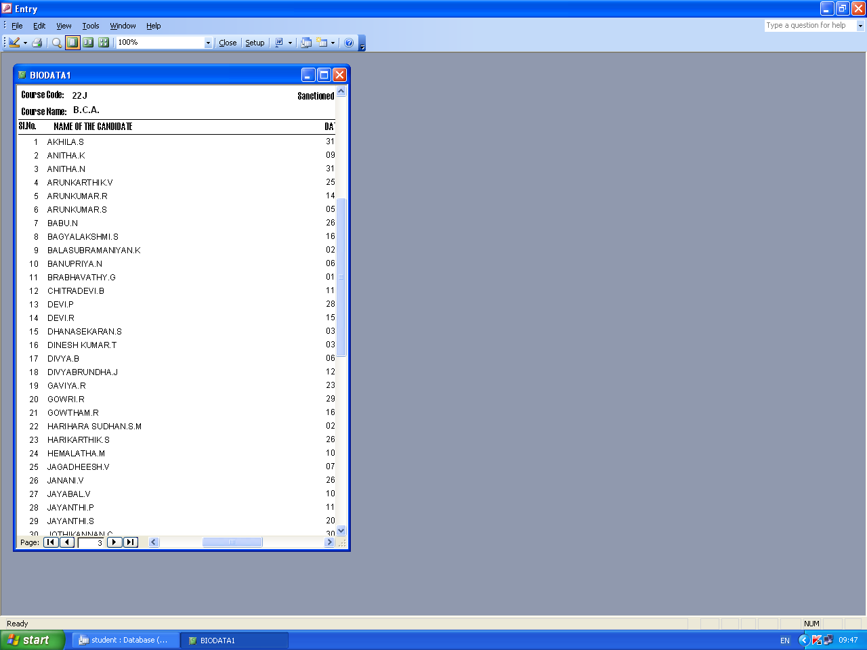

To enable macros in access to get fees automatically
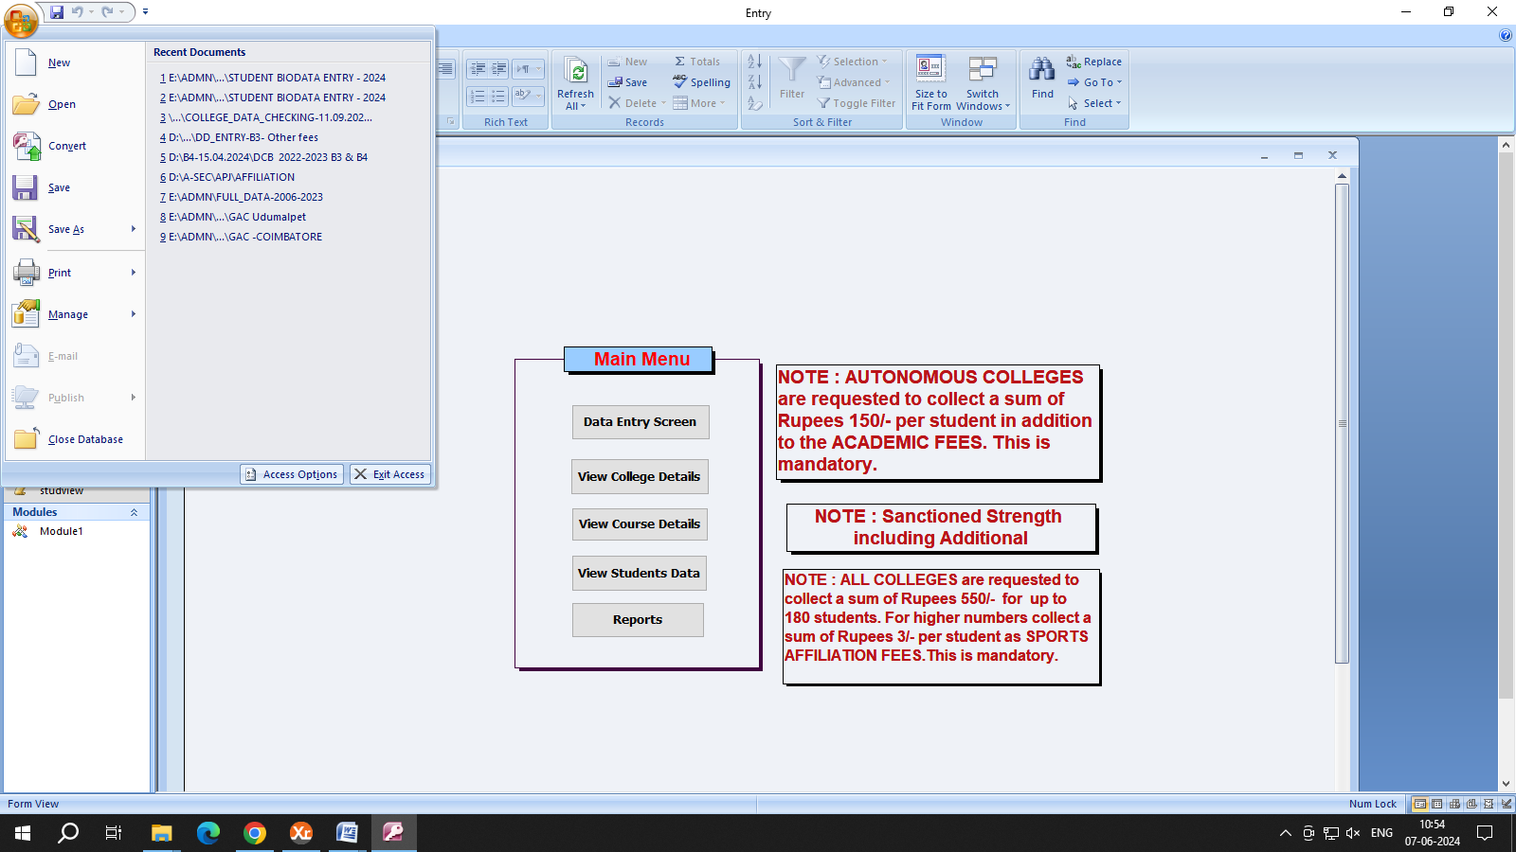

Step 1: Click Office button at the left top corner and select Access Options
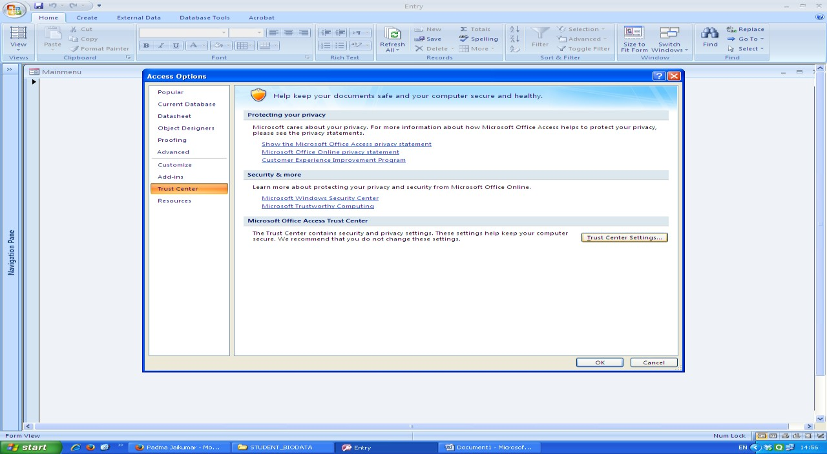
Step 2: Click Trust Center and then click Trust Centre Settings

5
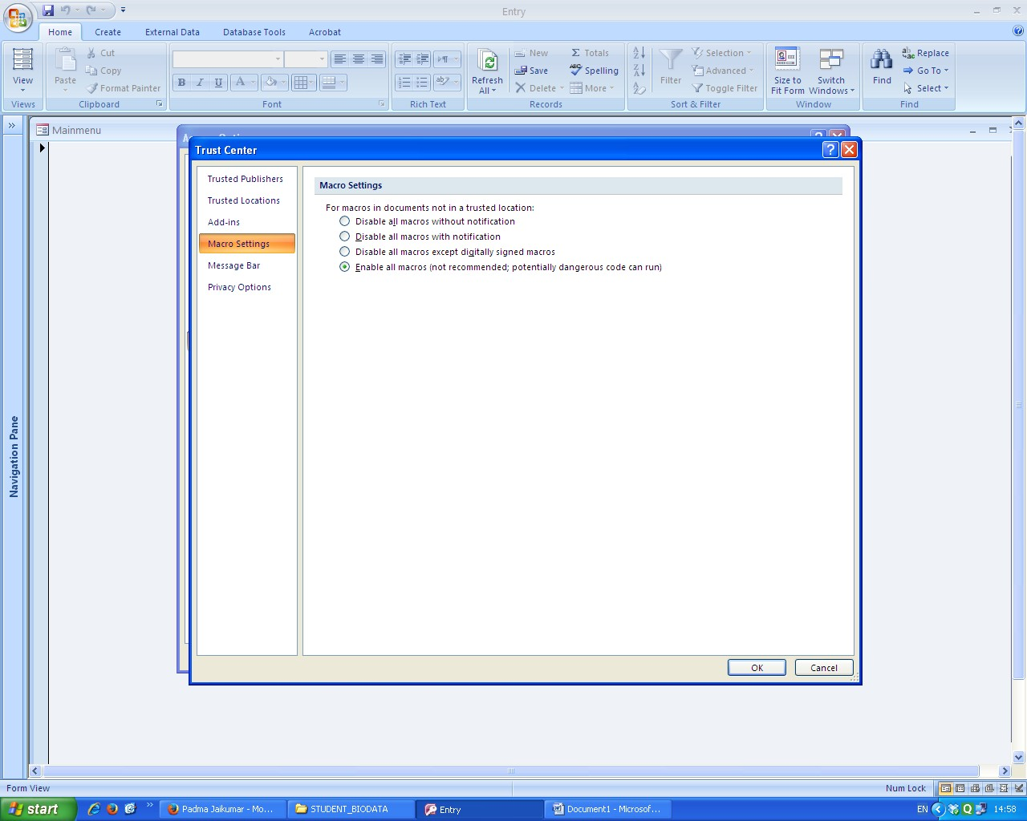

Step 3: Select Macro Settings and click last option Enable all macros
Step 4: Click ok button and close access and reopen.

6

