
BharathiarUniversity
(Accredited with“A++”Grade by NAAC|Ranked 46th among Indian Universities by MHRD-NIRF)
Coimbatore - 641046, TamilNadu, India

CET – JULY - 2026

Guidelines Support : Technical Query

Step1 : Login with your valid gmail account to submit the Query

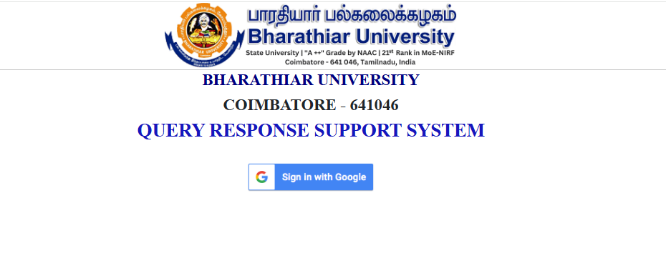
Step 2: Choose Post Query Tab
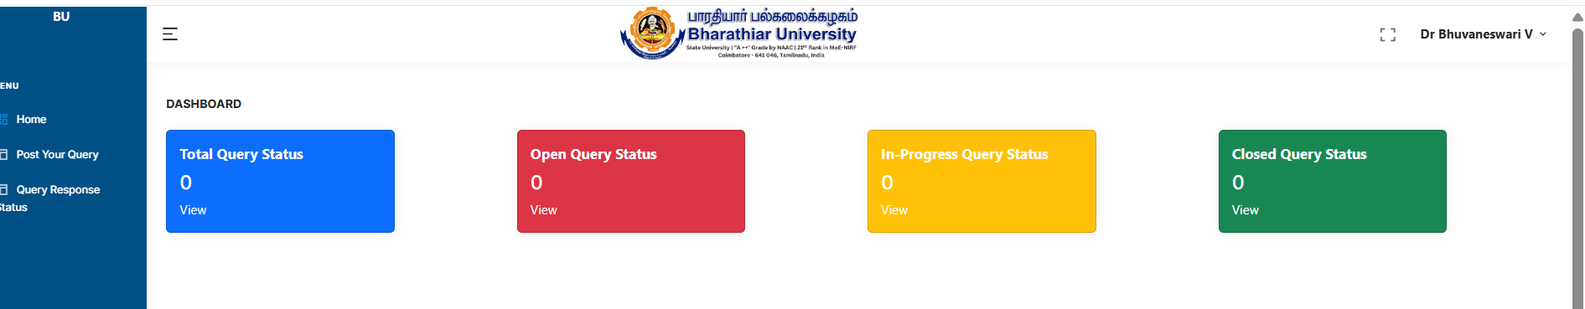

Step 3: Fill in the Required personal information and select Post Query
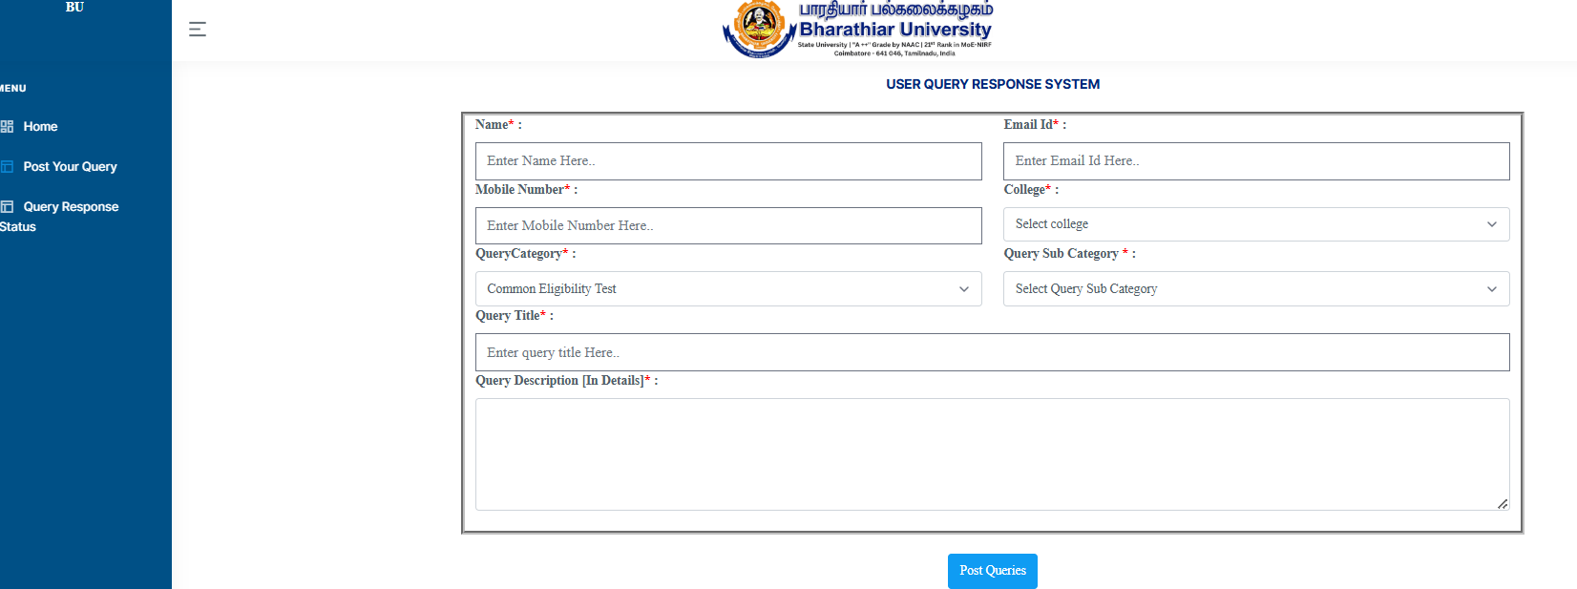
Select CET-Application for College
Select Common Eligibility Test for Query Category

Step 4: Click Query Response Status to View the query Response
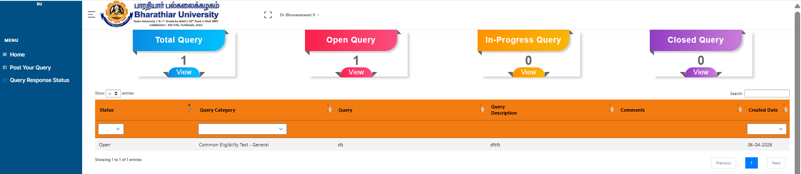

Most Important: In all your email/queries please mention the following without fail:
- Your full name as it appears on the CET 2026 application
- CET 2026 Application Number (if you have already applied for CET)
- Your registered email ID used for CET 2026
- Your CET subject

