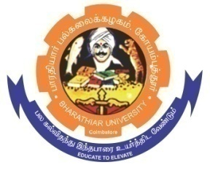
ghujpahh; gy;fiyf;fHfk;
BHARATHIAR UNIVERSITY
COIMBATORE – 641 046, TAMILNADU, INDIA

State University | Re-Accredited with “A” Grade by NAAC | Ranked 14th among Indian Universities by MHRD-NIRF
Advertisement for the Position of Project Assistant (PA)
RUSA 2.0 - BCTRC
Applications are invited for the post of Project Assistant to work in the RUSA 2.0 - BCTRC under the Department of Textiles and Apparel Design, Bharathiar University, Coimbatore - 641 046.

Name of the project : “Designing of radiation protective clothing”
Project duration : One year
Project positions and number : Project Assistant (1)
Qualification : M.Sc. Textiles and Apparel Design
M.Sc.Medical Physics
M.Sc.Physics
M.Sc.Bio Technology
M.Sc.Nanoscience and Technology

Fellowship : Rs.12,000/- p.m.(Consolidated)
The interested candidates may apply with a Bio-data along with passport size photograph and the copies of mark sheets, relevant certificated and any experience certificates from research publications through e-mail on or before 18.01.2022, 05.00PM.
Name of the PI’s, mail id & Designation | Address for communication
- Dr.K.Sangeetha  Professor and Head  Mail id: sangeethatad@buc.edu.in  - Dr.S.Grace Annapoorani  Professor  Mail id: gracetad@buc.edu.in  - Dr.M.Sumithra  Assistant Professor  Mail id: sumitad@buc.edu.in  - Dr.K.Amutha  Assistant Professor  Mail id: amuthatad@buc.edu.in  - Dr.M.Jayakumari  Assistant Professor  Mail id: jkkumaritad@buc.edu.in | Department of Textiles and Apparel Design  Bharathiar University  Coimbatore - 641 046.

PI’s RUSA 2.0 - BCTRC
Note: The shortlisted candidates will be informed and called for interview and no other communication in this regard will be entertained.

