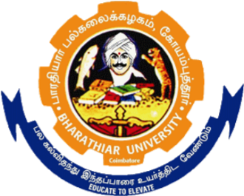
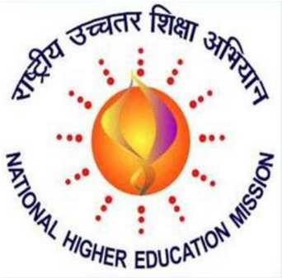
BHARATHIAR UNIVERSITY
(A State University, Accredited with “A” Grade by NAAC.
Ranked 13th in NIRF, 801-1000 in TIMES and 801-1000 in Shanghai Ranking)
Coimbatore 641046

RASHTRIYA UCHCHATAR SHIKSH ABHIYAN (RUSA)

Bharathiar Cancer Theranostics Research Centre – BCTRC
Recruitment of Temporary Technical Officers / Last Date
Technical Assistants / Programmer / Lab Attender August 30th 2022
The Bharathiar University is establishing interdisciplinary centre named Bharathiar Cancer Theranostics Research Centre funded by RUSA, MHRD in a holistic manner involving experts from various fields. The centre is to be established with laboratories housing state of art facilities to undertake research on Cancer. It envisages to document the unexplored traditional and tribal therapeutic methods practised to tap the potential solutions for the disease. As a part of this centre, University is in the process of recruiting Temporary Technical Officers / Technical Assistants / Programmer / Lab Attender with the attached qualifications.
Duration
The duration will be one year which shall be extended as per the requirement.
Emoluments
Selected candidates will receive a consolidated monthly salary as follows:
Technical Officer: 40,000/ -.
Programmer:Rs.36,000/-
Technical Assistant: Rs.15,000/-
Lab Attender: Rs.10,000/-

Additional Information
The University reserves the right to screen and call only eligible candidates for an interview as are found suitable. Thus, just fulfilling the minimum eligibility criteria would not entitle one to be selected.
The candidate is responsible for the correctness of the information provided in the application. If it is found at a later date that any information given in the application is incorrect or false, the candidature/appointment is liable to be cancelled/terminated.
How to Apply
Candidates should apply using the format available in the website. The following documents are required along with the application. (i) Filled–in– application available in the website.
- Full Curriculum Vitae
- Experience / Service certificate
- Any other relevant information of the applicant may like to furnish
The filled-in-application form along with the required documents must be sent to the RUSA Office, Bharathiar University, Coimbatore 641046 and soft copy should be emailed to: “rusa2.0bctrc@buc.edu.in”. For any further information related to this, please contact the Phone: +91-95971 74445.
LAST DATE FOR THE SUBMISSION OF APPLICATION: 30.08.2022

