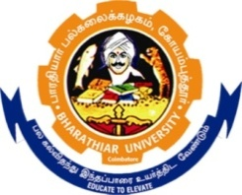
RUSA 2.0 BCTRC VACCANCY IN DEPARTMENT OF BIOPTECHNOLOGY, BHARATHIAR UNIVERSITY COIMBATORE-641046

Recruitment Notifications

Applications are invited for Project Assistant (PA) under RUSA 2.0 BCTRC project entitled “Pathway engineering for increasing the plumbagin (anticancer drug) content in Plumbago indica for production”.

Eligibility : Project Assistant (1 post) – Candidates with Postgraduate degree in Biotechnology are encouraged to apply.

Age Limit : 28 years (Relaxation will be given as per norms)

Fellowship : Rs. 12, 000/- per month
Tenure : 3 Months

Application format and Submission: Interested candidates can send hard copies of detailed resume along with recent photographs and certificate copies, copy of recent testimonial from your last studied faculty to the below mentioned address before 21.11.2022.
Application to be submitted;
Dr.S.Girija,
Associate Professor and PI – RUSA 2.0 BCTRC project,
Plant Biotechnology Lab,
Department of Biotechnology,
Bharathiar University,
Coimbatore-641046,
Tamil Nadu.
E-mail: sgirija@buc.edu.in

The mode of interview and the date will be intimated after scrutinizing the applications.

The selected candidate need to submit the original copy of two testimonial (one must from last studied), biodata, original certificates of all the required qualifications.

Dr. S. Girija
Principal Investigator

