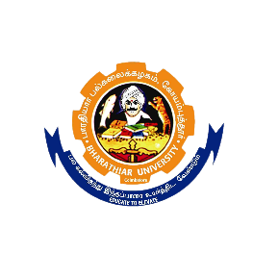
BHARATHIAR UNIVERSITY
Coimbatore – 641 046

RECRUITMENT OF GUEST FACULTY

Ref. No. BU/E11/G.F.HGMB/2023/19181-1 dated on: 20/10/2023

Applications are invited from the eligible candidates for appointment of the following Guest Faculty position in the Department of Human Genetics and Molecular Biology.

S. No. | Name of the post | No. of post(s) | Tenure | Qualification | Salary
1. | Guest Faculty | 01 | 01/07/2023 – 30/04/2024 | Masters in Human Genetics and Molecular Biology/Biotechnology/Biochemistry/Zoology with Ph.D  (or)  NET/SLET/SET/JRF | Consolidated pay of Rs. 25,000/-

Eligible candidates should submit their Curriculum Vitae, scanned copies of the certificates, publications and other relevant documents to the email, hgmb.dept@gmail.com and also send a hard copy on or before 17/11/2023.

Note: The date of the interview will be intimated through E-mail later.

REGISTRAR

