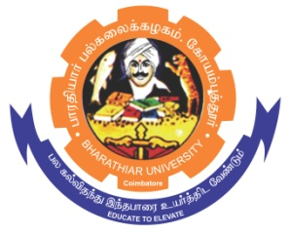
BHARATHIAR UNIVERSITY,
COIMBATORE – 641 046

DEPARTMENT OF HISTORY

The Department of History invites eligible candidates to apply with necessary attachments for the position of Guest Faculty in History.
Guest Faculty Recruitment 2023 - 2024
Qualification | : | Master Degree in History with NET, SET or Ph.D.
Date, Time and Place of Interview | : | Walk- In Interview will be conducted through offline mode. The date and time will be intimated later.
 |  | No TA/DA will be paid
Tenure | : | For the academic year 2023-24 (July 2023 to April 2024). Further, the service of Guest Faculty will be terminated at any time without assigning any reasons.
Salary | : | Rs. 25000/- per month
Documents to be produced | : | Detailed Resume with scanned copy of original certificates & Publications to history@buc.edu.in on or before 05.08.2023

REGISTRAR

