

**Advertisement for Recruitment of Junior Research Fellow**

Applications are invited for the post of Junior Research Fellow (JRF) to work under National Medicinal Plants Board – Ministry of AYUSH project entitled **“Deciphering the response of *Ficus* fruit polysaccharides on Major Histocompatibility Complex (MHC) in Inflammatory Bowel Disease (IBD)”**

Name of the Post: Junior Research Fellow (One)

Qualifications : M.Sc., Degree in Botany with the minimum of 55% marks.

Emoluments : Rs. 31,000 + 16% HRA per month

Duration : Three years

The interested Candidates are requested to send their application with a brief biodata with a recent photograph and contact details along with the attested copies of the relevant degree certificates/ mark statements, experience certificate and research publications (if any). The application should reach by post and mail ([drparimel@gmail.com](mailto:drparimel@gmail.com)) on or before **9th April 2023** to **Prof. T. Parimelazhagan,** Principal Investigator, NMPB – AYUSH Project, Department of Botany, Bharathiar University, Coimbatore -641 046.

**Note**: The shortlisted candidates will be called for an interview. The date of interview will be intimated by email/phone. No TA/DA will be paid to attend the interview.

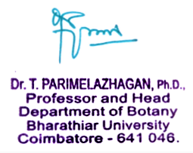

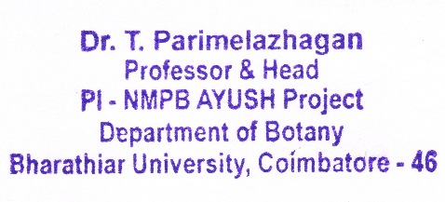Principal Investigator

