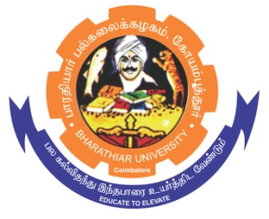**ghujpahh; gy;fiyf;fHfk;**

**BHARATHIAR UNIVERSITY**

**COIMBATORE – 641 046, TAMILNADU, INDIA**

|  |  |  |
| --- | --- | --- |
| **State University** | **Accredited with “A++” Grade by NAAC** | **Ranked 21st among Indian Universities by MoE-NIRF** |

e-TENDER NOTICE

E-Tender Notice No: C7/CRTD/Chemistry/DST-SERB/4355/2024 Date: 14.11.2024

Online bids are invited through Tamil Nadu Government e-procurement portal website [www.tntenders.gov.in](http://www.tntenders.gov.in) Tenders by Organization Higher Education for the Purchase of 1 No. of “Multimode Plate Reader” for the Department of Chemistry, Bharathiar University, Coimbatore.

The Tender documents can be downloaded from 14.11.2024. Bid submission will be started on 14.11.2024 @ 4.00 pm and will be closed on 28.11.2024 @3.00 pm

**REGISTRAR i/c**

