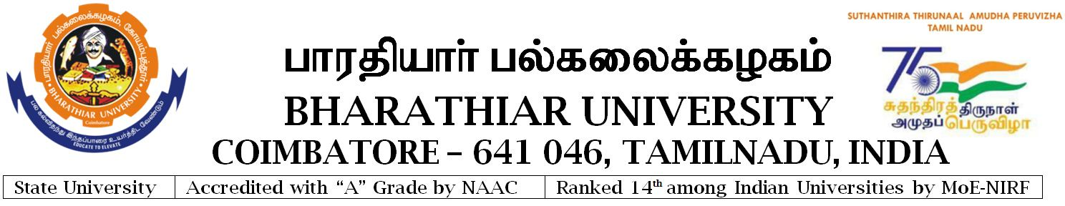

-----------------------------------------------------------------------------------------------------

**Notification No. Estt./E5/2022/SDE/12846-1 Date : 28.07.2022**

**RECRUITMENT NOTIFICATION**

Applications are invited for the Post of

**DIRECTOR, SCHOOL OF DISTANCE EDUCATION**

**--------------------------------------------------------------------------------------------**

**QUALIFICATION : As prescribed by the Syndicate of Bharathiar University.**

**PAY : Professor Scale of Pay / As per the Primary Cadre**

**AGE : Should have completed 50 years but below 57 years at the time of notification.**

**No. of Post : Single Post.**

**--------------------------------------------------------------------------------------------**

Application with qualification, eligibility conditions and instructions etc., are available in the University Website [www.b-u.ac.in](http://www.b-u.ac.in)

Last date for receipt of the filled in application along with Registration fee including Application fee of **Rs.600/-** for General category and **Rs.300/-** for OBC/SC/ST is **25.08.2022.**

**REGISTRAR** i/c