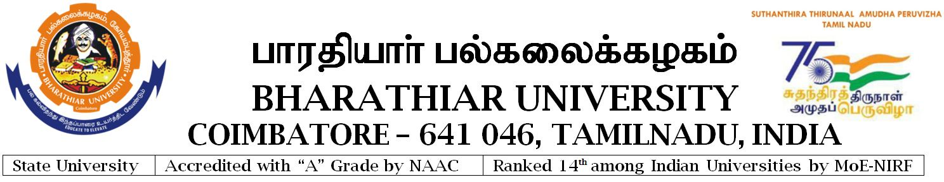
-----------------------------------------------------------------------------------------------------
Notification No. Estt./E5/2022/PRO/12846-3 Date 28.07.2022

RECRUITMENT NOTIFICATION

Applications are invited for the Post of PUBLIC RELATIONS OFFICER
-----------------------------------------------------------------------------------------
QUALIFICATION : As prescribed by the Syndicate of Bharathiar University.

PAY : Pay Level 25 (59300-217600).

AGE : Shall not exceed 42 years and 47 years for SC/ST on the date of notification.

No. of Post : Single Post.
-----------------------------------------------------------------------------------------
Application with qualification, eligibility conditions and instructions etc., are available in the University Website www.b-u.ac.in

Last date for receipt of the filled in application along with Registration fee including Application fee of Rs.600/- for General category and Rs.300/- for OBC/SC/ST is 25.08.2022.

REGISTRAR i/c

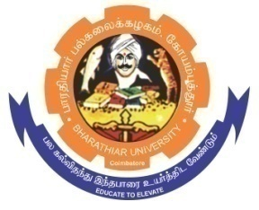
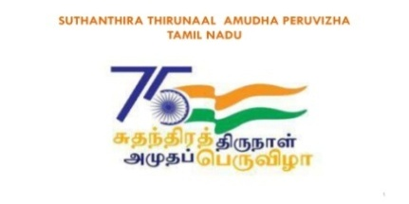
ghujpahh; gy;fiyf;fHfk;
BHARATHIAR UNIVERSITY COIMBATORE – 641 046, TAMILNADU, INDIA

State University | Accredited with “A” Grade by NAAC | Ranked 15th among Indian Universities by MoE - NIRF

APPLICATION FOR THE POST OF PUBLIC RELATIONS OFFICER

Registration Fees Particulars

Passport size
Photograph

Crossed DD for Rs. ____/-

DD. No: Date:

Name of the Bank:

Branch:

1. Name (Block letters) :

2. Date of Birth and Age :
as on 28.07.2022
: Y……….M……….D………
(Evidence to be furnished
Separately)

3. Sex : Male / Female

4. Nationality :

5. Community : FC / BC / BC(M )/MBC / DNC / SC / SC(A) / ST
(please enclose Xerox copy)

6. Present Post :

Scale of Pay :

Gross Salary :

7. (a). Educational Qualification :
(from First Degree)

Sl.No. | Examination Passed  (with main subject) | Month & Year | Marks/Grade  Class/Rank | Institution/  University

(b) Desirable Qualification :

(c) Knowledge in Tamil:

Studied Tamil: SSLC /+ 2/Degree and above / Other Certificates/Diploma 1/3

(d) Training undergone

(i) Administrative :

(ii) Public Relations & Human Resource Management :

(e) Information Technology & Management expertise gained in the field of Public
Relations & Human Resource Management:

(i) Additional Exam. Passed/Qualifications obtained if any :

(ii) Membership in Expert Committees :

(iii) Public Relations Activities :

(f) Award/Prizes/Distinctions received (if any)

(i) For Academic contributions :

(ii) For Administrative contributions :

(g) Membership or fellowship in Professional bodies :

8. Administrative Experience (University/College Level):

Sl.No. | Post held with name of  the Institution indicate Temporary / Permanent | Nature of Assisgnment | Duration |  | Total No. of Years
 |  |  | From | To

9. Other Experiences :

Sl. No. | Position held | Institution | Duration |  | Total No. of Years
 |  |  | From | To
 | Deputation to Foreign Countries or National level institutions (Please mention the Countries / Institutions and the Scheme of deputation in the field of Public Relations Activities & Human Resource Development)

10. Workshops and Training programmes undergone in the area of Educational administration, e-governance & Office Automation and Public Relations : (Evidence to be enclosed)

2/3

11. Mention your achievement in your present job (kindly indicate only those which are relevant to the post you applying for):

12. Have you been debarred or punished for adopting unfair means in your service or punished during your service any other charge? or filed any case against the University. If yes, please specify.

13. Are there any disciplinary proceedings initiated or pending against you in your places of services? If yes, please specify.

14. Names of the persons to whom reference can be made:
(1) | (2)

15. Any other information:

16. Address for communication:
Contact No:

I DECLARE THAT THE STATEMENTS MADE IN THIS APPLICATION ARE TRUE TO THE BEST OF MY KNOWLEDGE AND BELIEF. NO DISCIPLINARY PROCEEDINGS IS PENDING AGAINST ME AND I UNDERTAKE THE RESPONSIBILITY FOR THE VERACITY OF ALL STATEMENTS MADE IN THIS APPLICATION.
Place:
Date :
SIGNATURE OF THE APPLICANT

Forwarded with the remarks that this Institution/ Organization has ‘No Objection’ to the candidature being considered for the post applied for and also consent accorded on lien condition to relieve the applicant, if selected.
Place:
Date :
SIGNATURE WITH OFFICE SEAL
Designation/ Address

3/3
ghujpahh; gy;fiyf;fHfk;
BHARATHIAR UNIVERSITY COIMBATORE – 641 046, TAMILNADU, INDIA

State University | Accredited with “A” Grade by NAAC | Ranked 15th among Indian Universities by MoE - NIRF

GUIDELINES/GENERAL INSTRUCTIONS TO THE CANDIDATES APPLYING FOR THE POST OF

PUBLIC RELATIONS OFFICER

1. APPLICATIONS:

- Filled in application together with Registration fee including application fee of Rs.600/- for general category and Rs.300/- for OBC/SC/ST in the form of a Demand Draft drawn in favour of the Registrar, Bharathiar University, Coimbatore should be sent on or before 25.08.2022.

- Candidates are requested to fill the application in all respects. Incomplete applications will be summarily rejected.

- Ten copies of application shall be submitted to the Registrar, Bharathiar University, Coimbatore- 641 046.

2. QUALIFICATIONS:

- Essential : “Good academic record plus Master’s Degree with at least 55% of marks or its equivalent grade of B in the UGC seven point scale”.

- Desirable: Post Graduate Diploma in Human Resource Development or Diploma in Mass Communication / Public Relations of a recognized University / Institution.

- Knowledge of Tamil to the extent of carrying out official correspondence and drafting reports.

3. AGE : Shall not exceed 42 years and 47 years for SC/ST on the date of Notification.

4. AGE OF RETIREMENT: As per the norms of the Government of Tamil Nadu.

5. PAY : Pay Level 25 (59300 – 217600)

6. Filled in Applications (10 Copies) along with copies of the following required particulars should be submitted to the Registrar.

(i). Proof of age with an attested copy of the first page of SSLC Book:

(ii). Qualifications, degrees (With year / years of passing and University in which the degrees were taken);

(iii). Other academic distinctions, publications, if any;

(iv). Present occupation and salary with scale of pay;

(v). Language with which the applicant is conversant, together with copies of recent testimonials;

(vi). Names of two persons to whom a reference can be made.

(vii). No objection Certificate obtained from Appropriate Authority / Management shall be produced at the time of application.

(Candidates are advised to download or make photocopies of the application form. Self designed application formats will not be entertained)
1/2

7. Application should be addressed to the Registrar (by designation only), Bharathiar University, Coimbatore – 641 046.

8. Application from candidates, who are in service, shall submit the form through proper channel. In case of any delay, they may send 04 advance copies to the Registrar. However, their application will be considered and they will be called for interview only if their applications are forwarded through proper channel and received in time. It shall be ensured that such applications are sent through proper channel well in advance before the date of interview.

9. Applicants should be prepared to come for an interview at Coimbatore at their own cost. Applicants who attempt to canvas or influence their candidature in any manner will be disqualified.

10. The selection procedure will be as per the decision of the Syndicate of Bharathiar University.

11. The selected candidates will be required to join duty immediately and enter into an agreement with the University in accordance with the laws of the University on joining the post.

12. The last date for submission of filled-in application is 25.08.2022. The applications received after the last date and applications with incomplete particulars will be summarily rejected.

13. Candidates in service are informed that pay protection in any manner will not be provided on selection to the post concerned.

14. Enquires made over telephone or in person will not be entertained.

15. The syndicate reserves the right to fill or not to fill up the post without assigning any reason whatsoever.

16. Application fee including registration fee is non-refundable under any circumstances.

- Incumbents under OBC category are requested to avail concession on registration fee only if they possess current valid OBC-certificate.

- After Notification and until the publication of result, no information will be furnished under Right to Information Act.

- The University will not be responsible for any delay in receipt of the application on or before the last date due to public holiday/strike/any other unforeseen reason and the applications are liable to be rejected.

20. DATES TO BE REMEMBERED:

- Date of commencement of downloading the application form 28.07.2022.

(b) Last date for receipt of filled in application form 25.08.2022.

---------------------------------------------------------------------------------------------------

2/2

