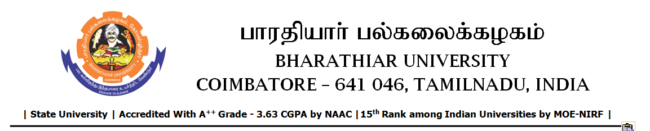

**TENDER INVITING NOTICE**

**e-Tender Notice No.BU/UE/AEE/7D/D-598/2025-2026 dated 29.08.2025**

Online bid is invited through portal <https://tntenders.gov.in> from interested bidders upto 3.00 P.M on 17.09.2025 for the following work.

|  |  |  |  |  |
| --- | --- | --- | --- | --- |
| Sl. No | Name of Work | Estimate Amount (Approx.) Rs. in lakhs | Period of Contract | EMD  Rs. |
| 1 | Formation of Four wheeler (Jeep) Track in boundary line around Academic campus in Bharathiar University. | 2.17 | 3 Months | 2170/- |