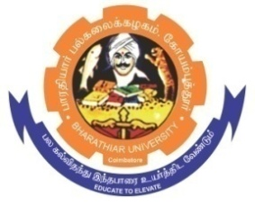
ghujpahh; gy;fiyf;fHfk;
BHARATHIAR UNIVERSITY
COIMBATORE – 641 046, TAMILNADU, INDIA

State University | Re-Accredited with “A++” Grade by NAAC | Ranked 21st among Indian Universities by MHRD-NIRF

e- TENDER INVITING NOTICE

E-Tender Notice No:BU/R-D8/13947&14986/DCA-table&chair/2025-26 Date: 01.12.2025

Online Bids are invited through Tamil Nadu Government e-Procurement Portal website: www.tntenders.gov.in Tenders by Organisation Higher Education for the Purchase of 6 Nos. of Steel Executive ‘L’ shape table and 6 Nos. of Revolving Medium Back Mesh Executive Chair with Cushion for the Department of Computer Application in Bharathiar University, Coimbatore.
The Tender documents can be downloaded from 02.07.2025. Bid submission will be started on 02.07.2025 and will be closed on 17.07.2025
REGISTRAR

Website: www.b-u.ac.in E-Mail: regr@buc.edu.in Phone: 0422-2428108/2428126 Fax: +91 422 2425706

