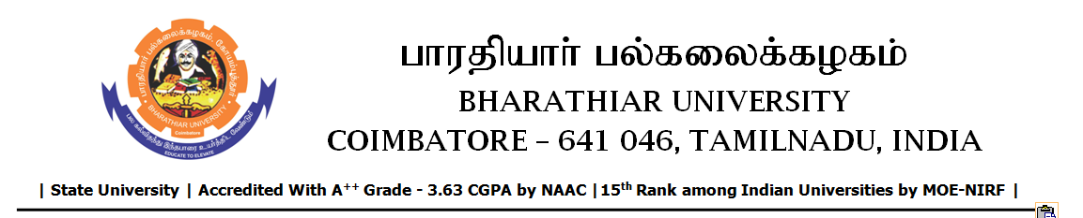

TENDER INVITING NOTICE

e-Tender Notice No.BU/UE/AEE/23^{D}/D-1188/2025-2026 dated 29.12.2025

Online bid is invited through portal https://tntenders.gov.infrom interested bidders upto 3.00 P.M on 13.01.2026 for the following work.

Sl. No | Name of Work | Estimate Amount (Approx.)  Rs. in lakhs | Period of Contract | EMD  Rs.
1 | Providing water proofing treatment to ground and first floor rooms in the Periyar Hostel in Bharathiar University | 5.57 | 4 Months | 5,570/-

