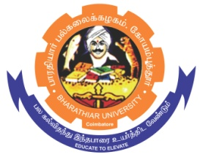**ghujpahh; gy;fiyf;fHfk;**

**BHARATHIAR UNIVERSITY**

**COIMBATORE – 641 046, TAMILNADU, INDIA**

|  |  |  |
| --- | --- | --- |
| **State University** | **Accredited with “A++” Grade by NAAC** | **Ranked 21st among Indian Universities by MoE-NIRF** |

e-TENDER NOTICE

E-Tender Notice No: C7/CRTD/Zoology/CMRG/C&G/1004/2025 Date: 06.06.2025

Online bids are invited through Tamil Nadu Government e-procurement portal website [www.tntenders.gov.in](http://www.tntenders.gov.in) Tenders by Organization Higher Education for the Purchase of Chemicals for the Department of Zoology, Bharathiar University, Coimbatore.

The Tender documents can be downloaded from 06.06.2025. Bid submission will be started on 06.06.2025 @ 4.00 pm and will be closed on 21.06.2025 @3.00 pm.

**REGISTRAR i/c**

