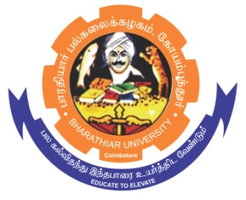**ghujpahh; gy;fiyf;fHfk;**

**BHARATHIAR UNIVERSITY**

**COIMBATORE – 641 046, TAMILNADU, INDIA**

|  |  |  |
| --- | --- | --- |
| **State University** | **Accredited with “A++” Grade by NAAC** | **Ranked 21st among Indian Universities by MoE-NIRF** |

e-TENDER NOTICE

E-Tender Notice No: C7/CRTD/Human Genetics/ICMR DHR/1210/2025 Date: 25.06.2025

Online bids are invited through Tamil Nadu Government e-procurement portal website [www.tntenders.gov.in](http://www.tntenders.gov.in) Tenders by Organization Higher Education for the Purchase of Chemicals for the Department of Human Genetics and Molecular Biology, Bharathiar University, Coimbatore.

The Tender documents can be downloaded from 08.07.2025. Bid submission will be started on 08.07.2025 @ 4.00 pm and will be closed on 23.07.2025 @ 3.00 pm.

**REGISTRAR i/c**

