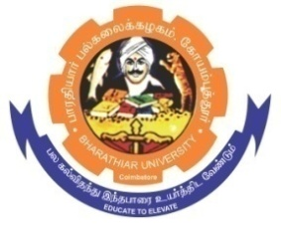
ghujpahh; gy;fiyf;fHfk;
BHARATHIAR UNIVERSITY
COIMBATORE – 641 046, TAMILNADU, INDIA

State University | Re-Accredited with “A++” Grade by NAAC | Ranked 21st among Indian Universities by MHRD-NIRF

TENDER INVITING NOTICE

E-Tender Notice No: BU/R-D8/DBC-lab-fur/18898/2023-24 Date : 07.11.2023

Online Bids are invited through Tamil Nadu Government e-Procurement Portal website: www.tntenders.gov.in Tenders by Organisation Higher Education for the Purchase of 1 No. of Laboratory Modular wall table L shape continuous module and 1 No. of sink with 3 way tap and reagent rack for the Department of Biochemistry in Bharathiar University, Coimbatore.
The Tender documents can be downloaded from 07.11.2023. Bid submission will be started on 07.11.2023 and will be closed on 22.11.2023 @ 03.00PM

REGISTRAR i/c

Website: www.b-u.ac.in E-Mail: regr@buc.edu.in Phone: 0422-2428108/2428126 Fax: +91 422 2425706

