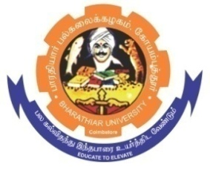
ghujpahh; gy;fiyf;fHfk;
BHARATHIAR UNIVERSITY
COIMBATORE – 641 046, TAMILNADU, INDIA

State University | Re-Accredited with “A++” Grade by NAAC | Ranked 21st among Indian Universities by MHRD-NIRF

TENDER INVITING NOTICE

E-Tender Notice No: BU/R-D8/E&I-fur/D-26140/2023-24 Date : 10.11.2023

Online Bids are invited through Tamil Nadu Government e-Procurement Portal website: www.tntenders.gov.in Tenders by Organisation Higher Education for the Purchase of various furniture for the Department of Electronics and Instrumentation in Bharathiar University, Coimbatore.
The Tender documents can be downloaded from 10.11.2023. Bid submission will be started on 10.11.2023 and will be closed on 24.11.2023 @ 03.00PM

REGISTRAR i/c

Website: www.b-u.ac.in E-Mail: regr@buc.edu.in Phone: 0422-2428108/2428126 Fax: +91 422 2425706

