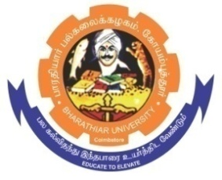**ghujpahh; gy;fiyf;fHfk;**

**BHARATHIAR UNIVERSITY**

**COIMBATORE – 641 046, TAMILNADU, INDIA**

|  |  |  |
| --- | --- | --- |
| **State University** | **Re-Accredited with “A++” Grade by NAAC** | **Ranked 21st among Indian Universities by MHRD-NIRF** |

TENDER INVITING NOTICE

E-Tender Notice No: BU/R-D2/Env.Sci/Equip/21811/2023-24 Date: 23.11.2023

Online Bids are invited through Tamil Nadu Government e-Procurement Portal website:

[**www.tntenders.gov.in**](http://www.tntenders.gov.in)[**Tenders by Organisation**](https://tntenders.gov.in/nicgep/app?page=FrontEndTendersByOrganisation&service=page) **Higher Education** for the purchase of 2 Nos. of GPS Garmin for the Department of Environmental Sciences in Bharathiar University, Coimbatore.

The Tender documents can be downloaded from 23.11.2023. Bid submission will be started on 23.11.2023 and will be closed on 29.11.2023 @ 3.00PM

**REGISTRAR i/c.**

**Website:** [**www.b-u.ac.in**](http://www.b-u.ac.in) **٭ E-Mail:** [**regr@buc.edu.in**](mailto:regr@buc.edu.in) **٭ Phone: 0422-2428108/2428126 ٭Fax: +91 422 2425706**