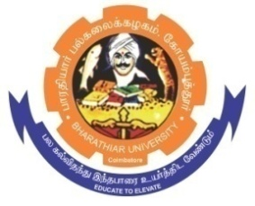**ghujpahh; gy;fiyf;fHfk;**

**BHARATHIAR UNIVERSITY**

**COIMBATORE – 641 046, TAMILNADU, INDIA**

|  |  |  |
| --- | --- | --- |
| **State University** | **Re-Accredited with “A++” Grade by NAAC** | **Ranked 21st among Indian Universities by MHRD-NIRF** |

TENDER INVITING NOTICE

E-Tender Notice No: BU/R-D2/CMS/Equip/18031/2023-24 Date: 16.11.2023

Online Bids are invited through Tamil Nadu Government e-Procurement Portal website:

[**www.tntenders.gov.in**](http://www.tntenders.gov.in)[**Tenders by Organisation**](https://tntenders.gov.in/nicgep/app?page=FrontEndTendersByOrganisation&service=page) **Higher Education** for the purchase of 1 No. of Professional LED Video Light for the Department of Communication and Media Studies in Bharathiar University, Coimbatore.

The Tender documents can be downloaded from 16.11.2023. Bid submission will be started on 16.11.2023 and will be closed on 22.11.2023 @ 3. 00 P.M.

**REGISTRAR i/c.**

To

The Co-ordinator,

Centre for Internet & Website Services – with a request to upload the Tender Notice

Bharathiar University. in the University Website.

Copy To

The Associate Professor and Head i/c,

Department of Communication and Media Studies, BU.

**Website:** [**www.b-u.ac.in**](http://www.b-u.ac.in) **٭ E-Mail:** [**regr@buc.edu.in**](mailto:regr@buc.edu.in) **٭ Phone: 0422-2428108/2428126 ٭Fax: +91 422 2425706**