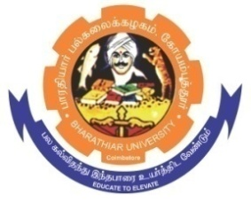
ghujpahh; gy;fiyf;fHfk;
BHARATHIAR UNIVERSITY
COIMBATORE – 641 046, TAMILNADU, INDIA

State University | Re-Accredited with “A++” Grade by NAAC | Ranked 21st among Indian Universities by MHRD-NIRF

TENDER INVITING NOTICE

E-Tender Notice No: BU/R-D2/Env.Sci/Equip/11871/2023-24 Date: 05.09.2023

Online Bids are invited through Tamil Nadu Government e-Procurement Portal website:
www.tntenders.gov.in Tenders by Organisation Higher Education for the purchase of 1 No. of COD Portable Photometer for the Department of Environmental Sciences in Bharathiar University, Coimbatore.

The Tender documents can be downloaded from 05.09.2023. Bid submission will be started on 05.09.2023 and will be closed on 20.09.2023 @ 3. 00 P.M.

REGISTRAR i/c.

Website: www.b-u.ac.in ٭ E-Mail: regr@buc.edu.in ٭ Phone: 0422-2428108/2428126 ٭Fax: +91 422 2425706

