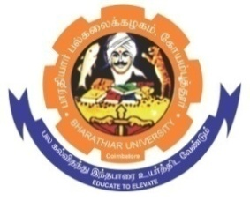**ghujpahh; gy;fiyf;fHfk;**

**BHARATHIAR UNIVERSITY**

**COIMBATORE – 641 046, TAMILNADU, INDIA**

|  |  |  |
| --- | --- | --- |
| **State University** | **Re-Accredited with “A++” Grade by NAAC** | **Ranked 21st among Indian Universities by MHRD-NIRF** |

TENDER INVITING NOTICE

E-Tender Notice No: BU/ D5/12919/Annual Report -2022/2023-24 Date: 15.09.2023

**Online** Bids are invited through **Tamil Nadu Government e-procurement** portal website: [**www.tntenders.gov.in**](http://www.tntenders.gov.in)[**Tenders by Organisation**](https://tntenders.gov.in/nicgep/app?page=FrontEndTendersByOrganisation&service=page) **Higher Education** for the Printing and Supply of **41st Annual Report for the year 2022** of Bharathiar University, Coimbatore.

The Tender documents can be downloaded from **15.09.2023**. Bid submission will be started on **11.15** **am on 15.09.2023** and will be closed on **03.00 pm on 30.09.2023**.

**REGISTRAR i/c**

**Website:** [**www.b-u.ac.in**](http://www.b-u.ac.in) **E-Mail:** [**regr@buc.edu.in**](mailto:regr@buc.edu.in) **Phone: 0422-2428108/2428126 Fax: +91 422 2425706**