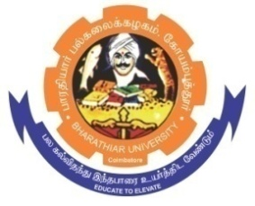**ghujpahh; gy;fiyf;fHfk;**

**BHARATHIAR UNIVERSITY**

**COIMBATORE – 641 046, TAMILNADU, INDIA**

|  |  |  |
| --- | --- | --- |
| **State University** | **Re-Accredited with “A++” Grade by NAAC** | **Ranked 21st among Indian Universities by MHRD-NIRF** |

TENDER INVITING NOTICE

E-Tender Notice No: BU/R-D2/Nano/Equip/14179/2023-24 Date: 19.09.2023

Online Bids are invited through Tamil Nadu Government e-Procurement Portal website:

[**www.tntenders.gov.in**](http://www.tntenders.gov.in)[**Tenders by Organisation**](https://tntenders.gov.in/nicgep/app?page=FrontEndTendersByOrganisation&service=page) **Higher Education** for the purchase of 2 Nos. of DC regulated single output variable power supply for the Department of Nanoscience and Technology in Bharathiar University, Coimbatore.

The Tender documents can be downloaded from 03.10.2023. Bid submission will be started on 16.09.2023 and will be closed on 03.10.2023 @ 3.00PM

**REGISTRAR i/c.**

**Website:** [**www.b-u.ac.in**](http://www.b-u.ac.in) **٭ E-Mail:** [**regr@buc.edu.in**](mailto:regr@buc.edu.in) **٭ Phone: 0422-2428108/2428126 ٭Fax: +91 422 2425706**