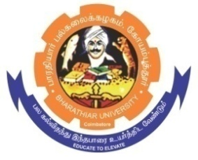**ghujpahh; gy;fiyf;fHfk;**

**BHARATHIAR UNIVERSITY**

**COIMBATORE – 641 046, TAMILNADU, INDIA**

|  |  |  |
| --- | --- | --- |
| **State University** | **Re-Accredited with “A++” Grade by NAAC** | **Ranked 21st among Indian Universities by MHRD-NIRF** |

TENDER INVITING NOTICE

E-Tender Notice No: BU/R-D2/BC/Equip/15519/2023-24 Date: 02.09.2023

Online Bids are invited through Tamil Nadu Government e-Procurement Portal website:

[**www.tntenders.gov.in**](http://www.tntenders.gov.in)[**Tenders by Organisation**](https://tntenders.gov.in/nicgep/app?page=FrontEndTendersByOrganisation&service=page) **Higher Education** for the purchase of 1 No. of Analytical Balance for the Department of Biochemistry in Bharathiar University, Coimbatore.

The Tender documents can be downloaded from 02.09.2023. Bid submission will be started on 02.09.2023 and will be closed on 15.09.2023 @ 3. 00 P.M.

**REGISTRAR i/c.**

**Website:** [**www.b-u.ac.in**](http://www.b-u.ac.in) **٭ E-Mail:** [**regr@buc.edu.in**](mailto:regr@buc.edu.in) **٭ Phone: 0422-2428108/2428126 ٭Fax: +91 422 2425706**