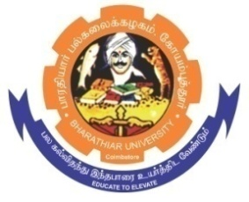**ghujpahh; gy;fiyf;fHfk;**

**BHARATHIAR UNIVERSITY**

**COIMBATORE – 641 046, TAMILNADU, INDIA**

|  |  |  |
| --- | --- | --- |
| **State University** | **Re-Accredited with “A++” Grade by NAAC** | **Ranked 21st among Indian Universities by MHRD-NIRF** |

e- TENDER INVITING NOTICE

**E-Tender Notice No:BU/R-D8/21935/Soci-table&desk/2024-2025 Date : 20.01.2025**

Online Bids are invited through Tamil Nadu Government e-Procurement Portal website: www.tntenders.gov.in Tenders by Organisation Higher Education for the **Purchase of 1 No. of Steel Executive table and 27 Nos. of Steel Dual Desk & Bench for the Department of Sociology and Population Studies**, Coimbatore.

The Tender documents can be downloaded from 24.01.2025. Bid submission will be started on 24.01.2025 and will be closed on 10.02.2025 @ 03.00PM.

**REGISTRAR i/c**

**Website:** [www.b-u.ac.in](http://www.b-u.ac.in) **E-Mail:** [regr@buc.edu.in](mailto:regr@buc.edu.in) **Phone: 0422-2428108/2428126 Fax: +91 422 2425706**