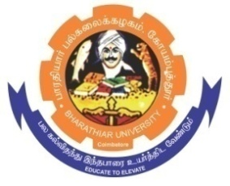**ghujpahh; gy;fiyf;fHfk;**

**BHARATHIAR UNIVERSITY**

**COIMBATORE – 641 046, TAMILNADU, INDIA**

|  |  |  |
| --- | --- | --- |
| **State University** | **Re-Accredited with “A++” Grade by NAAC** | **Ranked 21st among Indian Universities by MHRD-NIRF** |

E-TENDER NOTICE

E-Tender Notice No: BU/R-D2/Env.Sci/Equip./17322/2024-25 Date: 25.01.2025

Online Bids are invited through Tamil Nadu Government e-Procurement Portal website: [**www.tntenders.gov.in**](http://www.tntenders.gov.in)[**Tenders by Organisation**](https://tntenders.gov.in/nicgep/app?page=FrontEndTendersByOrganisation&service=page) **Higher Education** for the **Purchase of 1 No. of Algae biomass Harvesting Unit** for the Department of Environmental Sciences, in Bharathiar University, Coimbatore.

The Tender documents can be downloaded from **24.01.2025**. Bid submission will be started on **24.01.2025** and will be closed on **10.02.2025 @ 3.00 P.M.**

**REGISTRAR i/c.**

**Website:** [**www.b-u.ac.in**](http://www.b-u.ac.in)**٭ E-Mail:** [**regr@buc.edu.in**](mailto:regr@buc.edu.in)**٭ Phone: 0422-2428108/2428126 ٭Fax: +91 422 2425706**