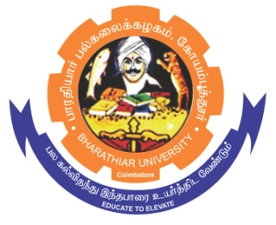**ghujpahh; gy;fiyf;fHfk;**

**BHARATHIAR UNIVERSITY**

**COIMBATORE – 641 046, TAMILNADU, INDIA**

|  |  |  |
| --- | --- | --- |
| **State University** | **Accredited with “A++” Grade by NAAC** | **Ranked 21st among Indian Universities by MoE-NIRF** |

e-TENDER NOTICE

E-Tender Notice No: C7/CRTD/Chemistry/DST-SERB-CRG/6949/2024-25 Date: 22.01.2025

Online bids are invited through Tamil Nadu Government e-procurement portal website [www.tntenders.gov.in](http://www.tntenders.gov.in) Tenders by Organization Higher Education for the Purchase of Chemicals and Glasswares for the Department of Chemistry, Bharathiar University, Coimbatore.

The Tender documents can be downloaded from 23.01.2025. Bid submission will be started on 23.01.2025 @ 5.00 pm and will be closed on 30.01.2025@ 3.00pm.

**REGISTRAR i/c**

