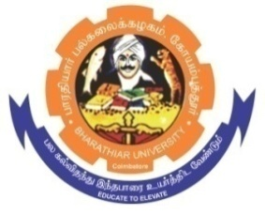
ghujpahh; gy;fiyf;fHfk;
BHARATHIAR UNIVERSITY
COIMBATORE – 641 046, TAMILNADU, INDIA

State University | Re-Accredited with “A++” Grade by NAAC | Ranked 26th among Indian Universities by MHRD-NIRF

E – TENDER NOTICE

Ref. No. BU/D5/16690/Monthly Calendar/2025-26 Date : 13.11.2025

Online Bids are invited through Tamil Nadu Government e-procurement portal website: www.tntenders.gov.in Tenders by Organisation Higher Education for the Printing and Supply of University Monthly Calendar – 2026 of Bharathiar University, Coimbatore.

REGISTRAR

Website: www.b-u.ac.in E-Mail: regr@buc.edu.in Phone: 0422-2428108/2428126 Fax: +91 422 2425706

