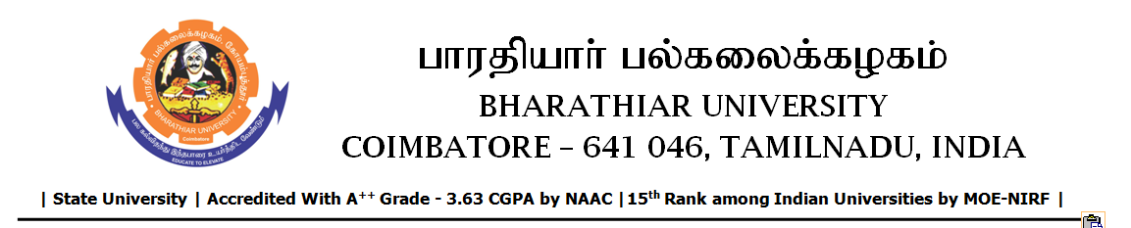

TENDER INVITING NOTICE

e-Tender Notice No.BU/UE/AEE/14^{D}/D- 931/2025-2026 dated 17.11.2025

Online bid is invited through portal https://tntenders.gov.in from interested bidders upto 3.00 P.M on 02.12.2025 for the following work.
Sl. No | Name of Work | Estimate Amount (Approx.)  Rs. in lakhs | Period of Contract | EMD  Rs.
1 | Providing new septic tank with dispersion trench to the Periyar hostel in Bharathiar University. | Rs.7.51 lakh | 3 Months | Rs.7510/-

