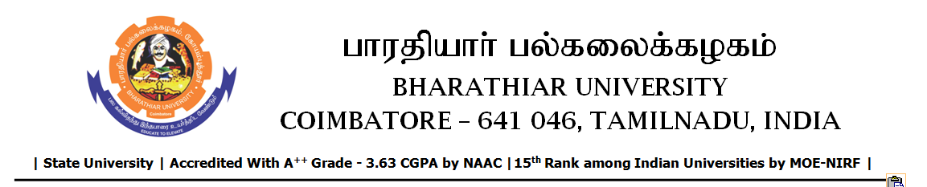

TENDER INVITING NOTICE

e-Tender Notice No.BU/UE/AEE/12^{D}/D-892/2025-2026 dated 23.10.2025

Online bid is invited through portal https://tntenders.gov.infrom interested bidders upto 3.00 P.M on 07.11.2025 for the following work.
Sl. No | Name of Work | Estimate Amount (Approx.)  Rs. in lakhs | Period of Contract | EMD  Rs.
1 | Providing drainage facilities and paver block to Registrar quarters (A-9) in Bharathiar University | 5.93 | 3 Months | 5930/-

