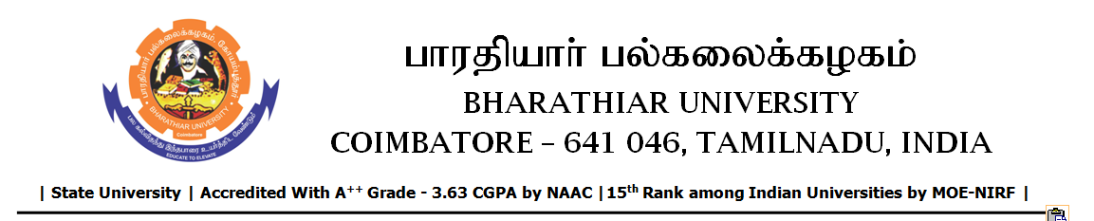

TENDER INVITING NOTICE

e-Tender Notice No.BU/UE/AEE/16^{D}/D- 919/2025-2026 dated 12.11.2025

Online bid is invited through portal https://tntenders.gov.in from interested bidders upto 3.00 P.M on 28.11.2025 for the following work.

Sl. No | Name of Work | Estimate Amount (Approx.)  Rs. in lakhs | Period of Contract | EMD  Rs.
1 | Special repair works to the Sports hostel in Bharathiar University. | Rs.4.76 lakh | 2 Months | Rs.4760/-

