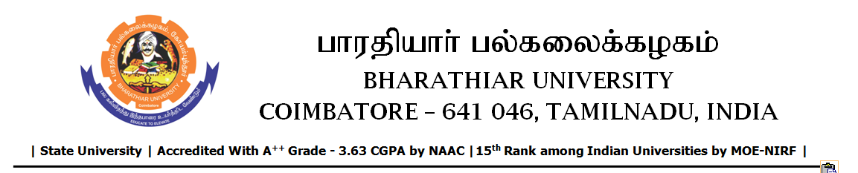

TENDER INVITING NOTICE

e-Tender Notice No.BU/UE/AEE/13^{D}/D-916/2025-2026 dated 12.11.2025

Online bid is invited through portal https://tntenders.gov.in from interested bidders upto 3.00 P.M on 27.11.2025 for the following work.
Sl. No | Name of Work | Estimate Amount (Approx.)  Rs. in lakhs | Period of Contract | EMD  Rs.
1 | Strengthening underground water storage sump in Elango Hostel in Bharathiar University. | 2.26 | 3 Months | 2,260/-

