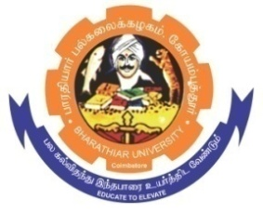
ghujpahh; gy;fiyf;fHfk;
BHARATHIAR UNIVERSITY
COIMBATORE – 641 046, TAMILNADU, INDIA

State University | Re-Accredited with “A++” Grade by NAAC | Ranked 26st among Indian Universities by MHRD-NIRF

E-TENDER NOTICE

E-Tender Notice No: BU/R-D2/CA/Equip /14158/2025-26 Date: 01.12.2025

Online Bids are invited through Tamil Nadu Government e-Procurement Portal website: www.tntenders.gov.in Tenders by OrganisationHigher Education for the purchase of 2 Nos. of 5 KVA Online UPS and 20 Nos. of Exide EL 100AH Tubular (with Battery stand, Interlink cable and Installation) under buy back scheme for the Department of Computer Applicationsin Bharathiar University, Coimbatore.

REGISTRAR

Website: www.b-u.ac.in٭ E-Mail: regr@buc.edu.in٭ Phone: 0422-2428108/2428126 ٭Fax: +91 422 2425706

