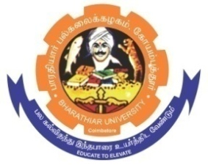
ghujpahh; gy;fiyf;fHfk;
BHARATHIAR UNIVERSITY
COIMBATORE – 641 046, TAMILNADU, INDIA

State University | Re-Accredited with “A++” Grade by NAAC | Ranked 26st among Indian Universities by MHRD-NIRF

E-TENDER NOTICE

E-Tender Notice No: BU/R-D2/CMS/Equipment /16786/2025-26Date: 01.12.2025

Online Bids are invited through Tamil Nadu Government e-Procurement Portal website: www.tntenders.gov.in Tenders by OrganisationHigher Education for the purchase of 1 No. of Godox VI-S Round Head Camera Flash Speed lite Flash for Sony DSLR Camera, 2 Nos. of Godox SK400II-V Studio Flash Monolight (2-Light Kit) and 4 Nos. of Simpex LED 1500 for the Department of Communication and Media Studies in Bharathiar University, Coimbatore.

REGISTRAR

Website: www.b-u.ac.in٭ E-Mail: regr@buc.edu.in٭ Phone: 0422-2428108/2428126 ٭Fax: +91 422 2425706

