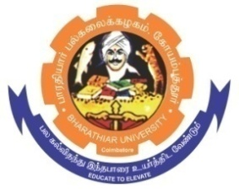
ghujpahh; gy;fiyf;fHfk;
BHARATHIAR UNIVERSITY
COIMBATORE – 641 046, TAMILNADU, INDIA

State University | Re-Accredited with “A++” Grade by NAAC | Ranked 26st among Indian Universities by MHRD-NIRF

E-TENDER NOTICE

E-Tender Notice No: BU/R-D2/Bioinf./ Software /15396/2025-26 Date: 01.12.2025

Online Bids are invited through Tamil Nadu Government e-Procurement Portal website: www.tntenders.gov.in Tenders by Organisation Higher Education for the purchase 1 No. of Molecular Modelling Software for the Department of Bioinformatics in Bharathiar University, Coimbatore.

REGISTRAR

Website: www.b-u.ac.in ٭ E-Mail: regr@buc.edu.in ٭ Phone: 0422-2428108/2428126 ٭Fax: +91 422 2425706

