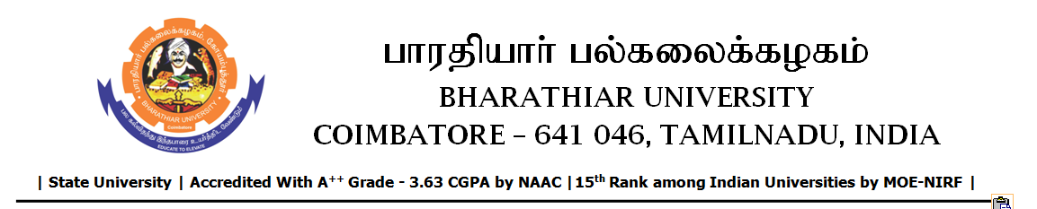

RE-TENDER INVITING NOTICE

e-Tender Notice No.BU/UE/AEE/14^{D}/D-1066/2025-2026 dated 04.12.2025

Online bid is invited through portal https://tntenders.gov.infrom interested bidders upto 3.00 P.M on 11.12.2025 for the following work.

Sl. No | Name of Work | Estimate Amount (Approx.)  Rs. in lakhs | Period of Contract | EMD  Rs.
1 | Providing new septic tank with dispersion trench to the Periyar Hostel in Bharathiar University. | 7.47 | 3 Months | 7,470/-

