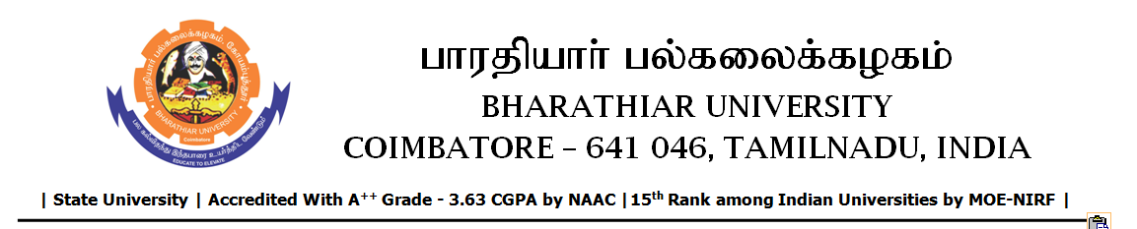

TENDER INVITING NOTICE

e-Tender Notice No.BU/UE/AEE/21^{D}/D- 1035/2025-2026 dated 02.12.2025

Online bid is invited through portal https://tntenders.gov.in from interested bidders upto 3.00 P.M on 09.12.2025 for the following work.
Sl. No | Name of Work | Estimate Amount (Approx.)  Rs. in lakhs | Period of Contract | Security Deposit amount in  Rs.
1 | Providing aluminium partition and false ceiling in VSM laboratory of Central Instrumentation Centre in Bharathiar University. | Rs.1.45 lakh | 1 Month | Rs.1450/-

UNIVERSITY ENGINEER

