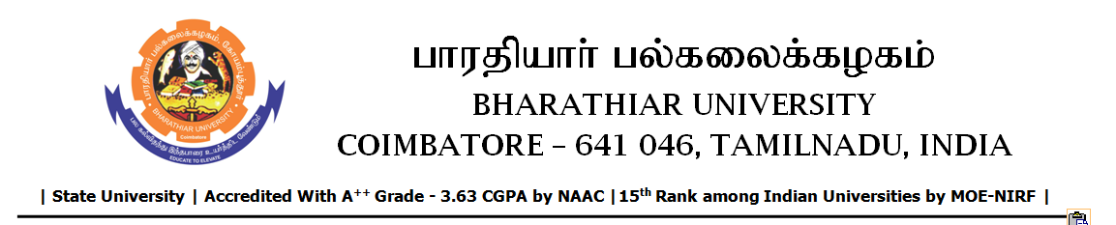

RE-TENDER INVITING NOTICE

e-Tender Notice No.BU/UE/AEE/18^{D}/D-1033/2025-2026 dated 02.12.2025

Online bid is invited through portal https://tntenders.gov.in from interested bidders upto 3.00 P.M on 09.12.2025 for the following work.

Sl. No | Name of Work | Estimate Amount (Approx.)  Rs. in lakhs | Period of Contract | EMD  Rs.
1 | Special repair works to the toilet blocks east and west of Sekhizhar hostel in Bharathiar University. | Rs.4.57 lakh | 2 Months | Rs.4570/-

UNIVERSITY ENGINEER

