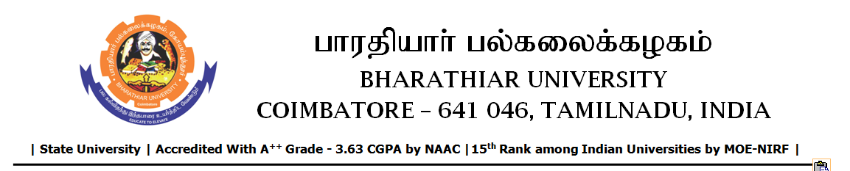

TENDER INVITING NOTICE

e-Tender Notice No.BU/UE/AEE/19^{D}/D-1042/2025-2026 dated 02.12.2025

Online bid is invited through portal https://tntenders.gov.infrom interested bidders upto 3.00 P.M on 09.12.2025 for the following work.
Sl. No | Name of Work | Estimate Amount (Approx.)  Rs. in lakhs | Period of Contract | EMD  Rs.
1 | Providing aluminium partition and false ceiling and spectoroscopy laboratory of Central Instrumentation Centre in Bharathiar University. | Rs.1.48 lakh | 1 Month | Rs.1,480/-

