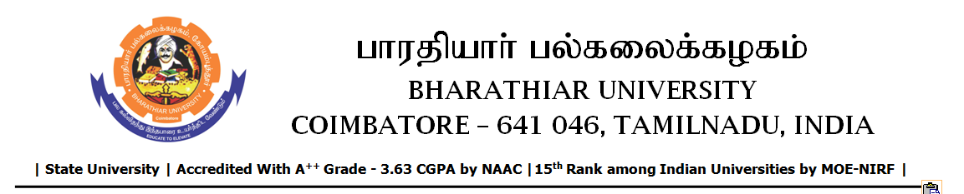

TENDER INVITING NOTICE

e-Tender Notice No.BU/UE/AEE/20^{D}/D-1006/2025-2026 dated 26.11.2025

Online bid is invited through portal https://tntenders.gov.infrom interested bidders upto 3.00 P.M on 11.12.2025 for the following work.
Sl. No | Name of Work | Estimate Amount (Approx.)  Rs. in lakhs | Period of Contract | EMD  Rs.
1 | Providing aluminium partition in ATC laboratory of Central Instrumentation Centre in Bharathiar University. | 2.20 | 3 Months | 2,200/-

