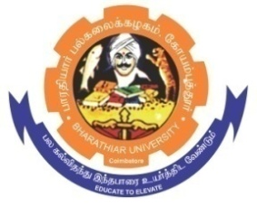
ghujpahh; gy;fiyf;fHfk;
BHARATHIAR UNIVERSITY
COIMBATORE – 641 046, TAMILNADU, INDIA

State University | Re-Accredited with “A++” Grade by NAAC | Ranked 26st among Indian Universities by MHRD-NIRF

E-TENDER NOTICE

E-Tender Notice No: BU/R-D2/Nano/ Equip /23411/2025-26 Date: 09.01.2026

Online Bids are invited through Tamil Nadu Government e-Procurement Portal website: www.tntenders.gov.in Tenders by Organisation Higher Education for the purchase of 1 No. of KickStart Data Logger Software [Perpetual Option: Floating] for the Department of Nanoscience and Technology in Bharathiar University, Coimbatore.

REGISTRAR
To
The In-charge,
Centre for Internet & Website Services – with a request to upload the Tender Notice
Bharathiar University. in the University Website.

Copy To

1. The Professor and Head, Dept. of Nanoscience and Technology, BU.
2. The Finance officer, BU.

Website: www.b-u.ac.in ٭ E-Mail: regr@buc.edu.in ٭ Phone: 0422-2428108/2428126 ٭Fax: +91 422 2425706

