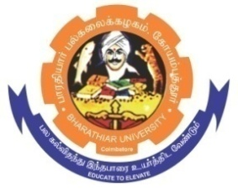
ghujpahh; gy;fiyf;fHfk;
BHARATHIAR UNIVERSITY
COIMBATORE – 641 046, TAMILNADU, INDIA

State University | Re-Accredited with “A++” Grade by NAAC | Ranked 26st among Indian Universities by MHRD-NIRF

E-TENDER NOTICE

E-Tender Notice No: BU/R-D2/CMS/ Equipment /11960/2025-26 Date: 09.01.2026

Online Bids are invited through Tamil Nadu Government e-Procurement Portal website: www.tntenders.gov.in Tenders by Organisation Higher Education for the purchase of 1 No. of ZBook Firefly 35.6 cm (14) G11 Mobile Workstation PC - Silver for the Department of Communication and Media Studies in Bharathiar University, Coimbatore.

REGISTRAR
To
The In-charge,
Centre for Internet & Website Services – with a request to upload the Tender Notice
Bharathiar University. in the University Website.

Copy To

1. The Professor and Head i/c, Dept. of Communication and Media Studies, BU.
2. The Finance officer, BU.

Website: www.b-u.ac.in ٭ E-Mail: regr@buc.edu.in ٭ Phone: 0422-2428108/2428126 ٭Fax: +91 422 2425706

