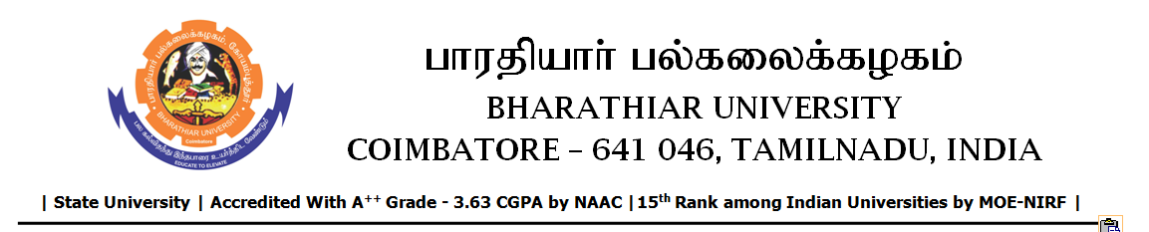

TENDER INVITING NOTICE

e-Tender Notice No.BU/UE/AEE/26^{D}/D-1279/2025-2026 dated 13.01.2026

Online bid is invited through portal https://tntenders.gov.infrom interested bidders upto 3.00 P.M on 20.01.2026 for the following work.
Sl. No | Name of Work | Estimate Amount (Approx.)  Rs. in lakhs | Period of Contract | EMD  Rs.
1 | Painting the interior portion of Usha Kirtilal Mehta Convention Centre in Bharathiar University in connection with 40th Convocation. | 1.43 | 2 Months | 1,430/-

