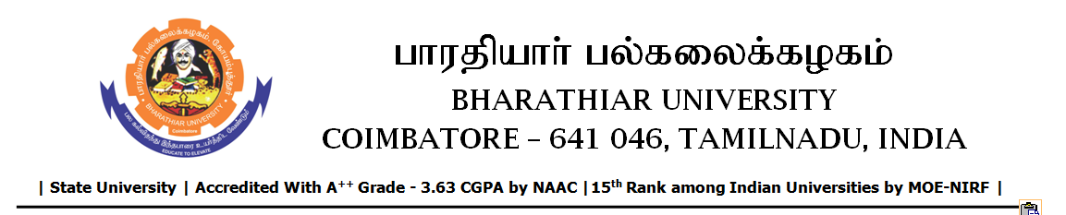

TENDER INVITING NOTICE

e-Tender Notice No.BU/UE/AEE/27^{D}/D-1280/2025-2026 dated 13.01.2026

Online bid is invited through portal https://tntenders.gov.infrom interested bidders upto 3.00 P.M on 20.01.2026 for the following work.

Sl. No | Name of Work | Estimate Amount (Approx.)  Rs. in lakhs | Period of Contract | EMD  Rs.
1 | Ordinary repairs to exterior portion of Usha Kirtilal Mehta Convention Centre and painting the Kerb stone in Bharathiar University in connection with 40th Convocation. | Rs.1.43 lakh | 2 Months | Rs.1,430/-

