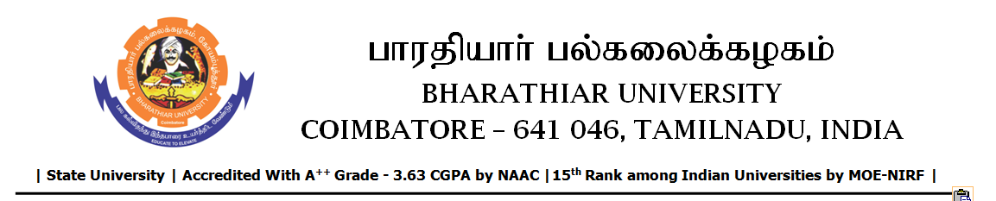

SHORT TERM TENDER INVITING NOTICE

e-Tender Notice No.BU/UE/AEE/29^{D}/D-1321/2025-2026 dated 28.01.2026

Online bid is invited through portal https://tntenders.gov.infrom interested bidders upto 3.00 P.M on 03.02.2026 for the following work.
Sl. No | Name of Work | Estimate Amount (Approx.)  Rs. in lakhs | Period of Contract | EMD  Rs.
1 | Providing semidense bituminous concrete for roads infront of Administrative building and entrance arch entry and exist gate area in Bharathiar University. | Rs.7.03 lakh | 3 Months | Rs.7,030/-

