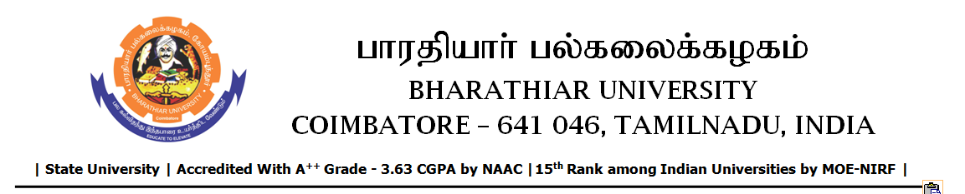

SHORT TERM TENDER INVITING NOTICE

e-Tender Notice No.BU/UE/AEE/30^{D}/D- 1322/2025-2026 dated 29.01.2026

Online bid is invited through portal https://tntenders.gov.in from interested bidders upto 3.00 P.M on 04.02.2026 for the following work.
Sl. No | Name of Work | Estimate Amount (Approx.)  Rs. in lakhs | Period of Contract | EMD  Rs.
1 | Providing semi dense bituminous concrete road from Bharathiar Statue to Elango hostel road junction in Bharathiar University. | Rs.9.67 lakh | 3 Months | Rs.9670/-

UNIVERSITY ENGINEER

