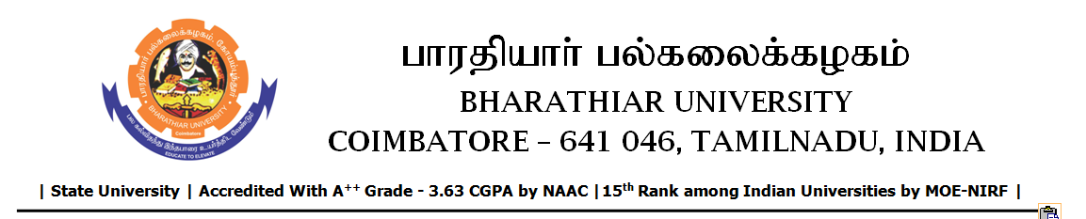

RE-TENDER INVITING NOTICE

e-Tender Notice No.BU/UE/AEE/28^{D}/D-1371/2025-2026 dated 10.02.2026

Online bid is invited through portal https://tntenders.gov.in from interested bidders upto 3.00 P.M on 17.02.2026 for the following work.
Sl. No | Name of Work | Estimate Amount (Approx.)  Rs. in lakhs | Period of Contract | EMD  Rs.
1 | Providing Cesspool to the Sports hostel in Bharathiar University. | Rs.1.47 lakh | 3 Months | Rs.1470/-

UNIVERSITY ENGINEER

