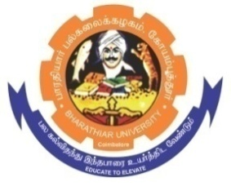
ghujpahh; gy;fiyf;fHfk;
BHARATHIAR UNIVERSITY
COIMBATORE – 641 046, TAMILNADU, INDIA

State University | Re-Accredited with “A++” Grade by NAAC | Ranked 26th among Indian Universities by MHRD-NIRF

E – TENDER NOTICE

E-Tender Notice No : 22790/ D5/Annual Report -2024/2025-26 Date: 12.02.2026

Online Bids are invited through Tamil Nadu Government e-procurement portal website: www.tntenders.gov.in Tenders by Organisation Higher Education for the Printing and supply of 360 Nos. of 43rd Annual Report of Bharathiar University, Coimbatore.

REGISTRAR
To

The Co-ordinator,
Centre for Internet & Website Services – with a request to upload the Tender Notice
Registrar’s office in the University Website

Copy To
Assistant Registrar
Registrar’s office,
C & G Section,

Website: www.b-u.ac.in E-Mail: regr@buc.edu.in Phone: 0422-2428108/2428126 Fax: +91 422 2425706

