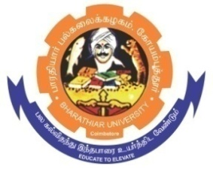
ghujpahh; gy;fiyf;fHfk;
BHARATHIAR UNIVERSITY
COIMBATORE – 641 046, TAMILNADU, INDIA

State University | Re-Accredited with “A++” Grade by NAAC | Ranked 46st among Indian Universities by MHRD-NIRF

E-TENDER NOTICE

E-Tender Notice No: BU/R-D2/BC/ Equip.Main /279/2025-26 Date: 26.02.2026

Online Bids are invited through Tamil Nadu Government e-Procurement Portal website: www.tntenders.gov.in Tenders by Organisation Higher Education for the Repair and Replacement of Motor for Bench Top Refrigerated Centrifuge for the Department of Biochemistry in Bharathiar University, Coimbatore.

REGISTRAR

Website: www.b-u.ac.in ٭ E-Mail: regr@buc.edu.in ٭ Phone: 0422-2428108/2428126 ٭Fax: +91 422 2425706

