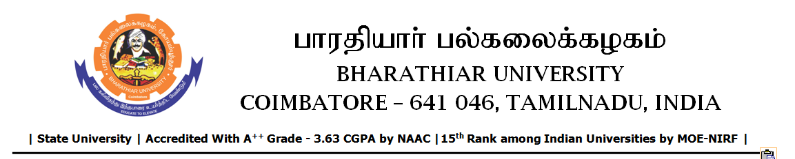

TENDER INVITING NOTICE

e-Tender Notice No.BU/UE/AEE/24^{D}/D-1401/2025-2026 dated 16.02.2026

Online bid is invited through portal https://tntenders.gov.in from interested bidders upto 3.00 P.M on 04.03.2026 for the following work.
Sl. No | Name of Work | Estimate Amount (Approx.)  Rs. in lakhs | Period of Contract | EMD  Rs.
1 | Providing water proofing treatment to the Expansion joint in Science block north and south, BSMED block, Library block, Environmental Science building and Controller of Examination building in Bharathiar University. | Rs.5.13 lakh | 4 Months | Rs.5130/-

UNIVERSITY ENGINEER

